**Configure MFA**

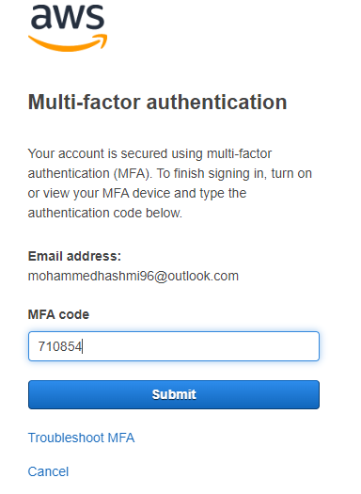

**2 Install aws cli**

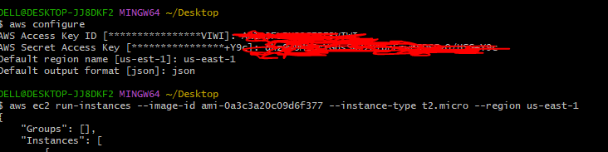

**3 Setup ec2 in N.virginia region using aws cli command.**

Command : aws ec2 run-instances --image-id ami-0a3c3a20c09d6f377 --instance-type t2.micro --region us-east-1

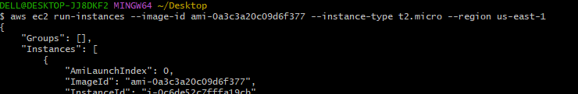

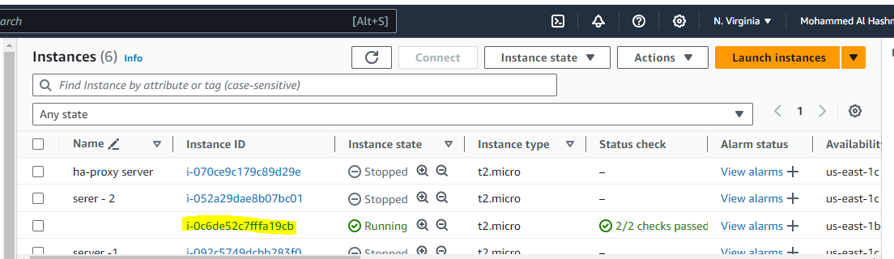

**4 Setup security group in ohio region with name techie-sg and open port 22**

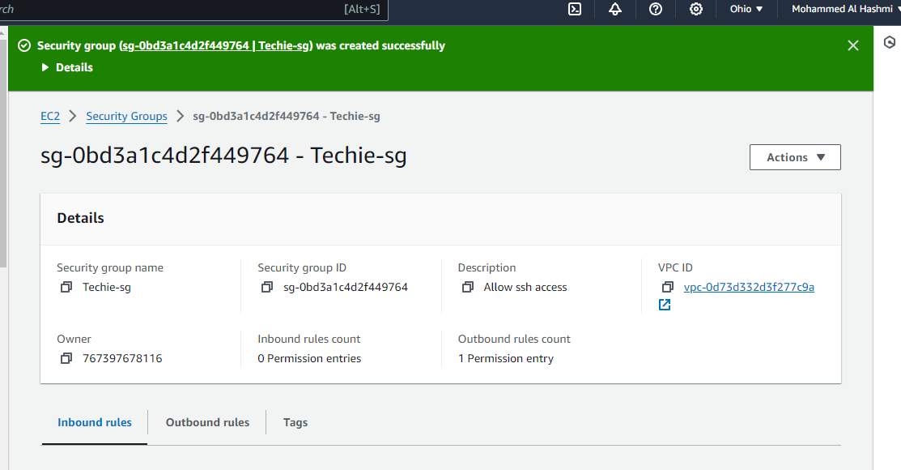

**5. Setup ec2, security group in Mumbai region using single aws cli command.**

Command for instance + security group: aws ec2 run-instances --image-id ami-0a3c3a20c09d6f377 --instance-type t2.micro --security-group-ids $(aws ec2 create-security-groupm--group-name Techie-sg --description "Techie security group" --vpc-id vpc-08f52b1fffe4dd40e --region ap-south-1 --output json --query 'GroupId') --region ap-south-1

Command for security group : aws ec2 create-security-group --group-name Mumai-sg --description "Techie security group" --vpc-id vpc-0899374221a0957bd --region ap-south-1

